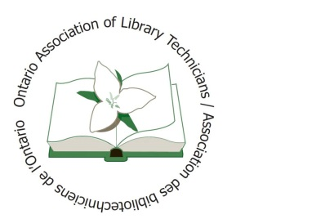 |  | Ontario Association of Library Technicians/  Association des bibliotechniciens de l’Ontario  Award for Innovation Nomination Form
The purpose of the Ontario Association of Library Technicians/Association des Bibliotechiciens de l’Ontario Award for Innovation is to recognize a member who has done something innovative in the workforce, for the association or for professional development. The Innovation Award was established in 2002 by Huronia Region in memory of Judy Koenig. The recipient will receive a commemorative plaque for their efforts.

The Award is presented annually to a full member in good standing (excluding the current Association President, members of the Award Committee and past recipients). The Award recognizes the contributions of Library Technicians from communities across Ontario, whose innovative efforts have contributed significantly to advancing the Association and/or our profession.

Any member (minimum of one, maximum of two) in good standing (not related to the candidate) may nominate a fellow member. Nominations must be submitted in writing to the Award Selection Committee by April 1st of each year. All nominations are CONFIDENTIAL.

Nominator(s):
Name: |  |  | Name:
Email: |  |  | Email:
Phone: |  |  | Phone:
Process:
An Award Selection Committee consisting of the previous Award recipient OR OALT/ABO Executive and two additional OALT/ABO members in good standing will look for the following criteria, but not limited to, when reviewing nominations:

- What was the major accomplishment?
- Was it one time vs ongoing or multiple day? i.e. workshop vs program
- Who were the people affected? i.e. in workplace, patrons, general public , community
- # of people involved/impacted and how (geographic area)
- Did this person initiate the process?
- Time involved
- How was project, innovation, etc. funded - could be an innovation itself!!

Outline the reason you think this person is deserving of the award, giving as much info as possible about the time involved, people affected and impact on the both the candidate and others. The more information the Awards Committee has the more criteria we have to judge on.
Please complete this to the best of your ability illustrating why you feel your candidate worthy of one of OALT/ABO’s highest honours. Completed forms must be submittedto info@oaltabo.on.ca unless otherwise requested.

Nominee:
Name:
Email:
Phone:
Membership History
How many years has the nominee been a member of OALT/ABO?
Does their history go back to the days of Regions? |  |  |  |  | Yes |  | No
They belonged to the following Region (s):
They currently belong to the following Chapters:
Description of Innovation

Additional Comments

