Angel Card Readings for Personal Guidance (For entertainment only)
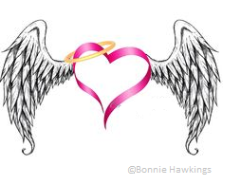
Kathryn, CACR

Before
- Have a clear mind and body
- Clear the space, invoke protection
- Tune in; take your time
- Clear and prepare the deck
- Shuffle; draw card(s)

During
- As soon as you start, the very second, every single thing you feel, hear, see, think is about the reading
  - e.g. hear airplane = trip; see bug = aunt; smell, touch, feel
- Look at imagery on card – what is it saying? park, outdoors, library, beach
- Are there numbers? (e.g. 4 months, years, days, June 4th, go forth, etc.)
- What is blocking you right now? These roadblocks teach you something
- What’s important? Physical wealth vs spiritual wealth
- What does card show? Family? Work? Are they causes for stress?

After
- Close with prayer
- Cut cords
- Ceremony it – write it down, burn it, let it go

Single card reading
- Single card is used to provide a concise reading, keeps the focus to the point. This type of reading can be helpful when requiring a more defined answer.

3 card reading (options)

General Reading:  Past or base | Current or what to work on | Outcome if nothing changes
Question:  energy surrounding the question | present challenge regarding your question | guidance regarding your question or situation
Relationships:  what you want out of the relationship; your true feelings | other person; how they are feeling, what they want out of the relationship; their energy | where the relationship is or where it is heading; what is missing or what could improve

